RESOLUTION NO.__________

RE: CERTIFICATE OF APPROPRIATENESS UNDER THE
PROVISIONS OF THE ACT OF THE PENNSYLVANIA
LEGISLATURE 1961, JUNE 13, P.L. 282 (53
SECTION 8004) AND BETHLEHEM ORDINANCE NO.
3952 AS AMENDED.

WHEREAS, it is proposed to repaint the exterior of the building at
47 East Market St.

NOW, THEREFORE, BE IT RESOLVED by the Council of the City of Bethlehem that a Certificate of Appropriateness is hereby granted for the proposal.

Sponsored by: (s)

(s)

ADOPTED BY COUNCIL THIS DAY OF

(s)
President of Council

ATTEST:

(s)
City Clerk

HISTORICAL & ARCHITECTURAL REVIEW BOARD

The applicant proposes to repaint the exterior of the building at
47 Market St.
APPLICATION #1:

George Heitczman
47 E. Market St.
Bethlehem, PA 18018

OWNER:

__________________________________________________________________

The Board upon motion by Phil Roeder and seconded by Nancy Shelly adopted the proposal that City Council issue a Certificate of Appropriateness for the following:

- Repaint the exterior of the building with the following color scheme:
Brick walls SW #2804
Exterior Trim SW #2805
Shingle Siding SW #0023
Ballusters SW #2838

2. Chosen color scheme is from the Sherwin Williams Heirloom Collection.

3. The motion was unanimously approved.

__________________________________________________________________________

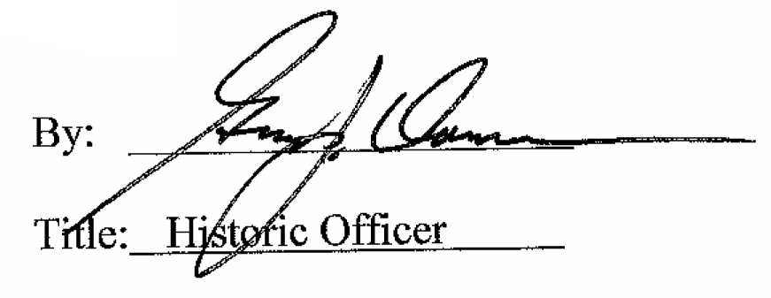

Date of Meeting: February 3, 2016

